MS.NET
Mini Project
HR Management System
(HRMS)

Document Revision History

Date | Revision No. | Author | Summary of Changes
3rd May 2018 | 1 | Amitabh Ninave | Initial Draft

Table of Contents
Introduction 4
Setup Checklist 4
Instructions 4
Problem Statement 5
Objective 5
Abstract of the project 5
Functional components of the project 6
Technology used: 7
Implementation 8
Summary of the functionality to be built: 8
Guidelines on the functionality to be built: 9
Evaluation and assessment parameters 13

Introduction
This document outlines a mini project for the .NET Line of Technology (LOT). The project is to develop an HR Management System (HRMS). This document contains the work flow of the system and gives guidelines on how to build the functionality gradually in each of the course modules of the .NET LOT.

Setup Checklist
Minimum System Requirements
- Intel Core i3 or above
- Memory 4 GB
- Windows 7 or above
- SQL Server 2012 (Or above) client and access to SQL Server 2012 server (Or above)
- Visual Studio 2013 or above

Instructions
- The code modules in the mini project should follow all the coding standards.
- Create a directory by your name in drive <drive>. In this directory, create a subdirectory MiniProject. Store your Project here.
- You can refer to your course material.
- You may also look up the help provided in the MSDN
- Since this project work will span over couple of months, you will need to take care of maintaining the code

Problem Statement

Objective
Development of a Windows application - HR Management System (HRMS)

Abstract of the project
This project is aimed at developing a Windows application - HR Management System (HRMS).

Stark Industries is primarily a defense company that develops and manufactures advanced weapons and military technologies. They want to develop a WPF application which will help HR department to manage their Employee information. This will enable HR department employees to view Add, Update, Delete, Search and List Employees of the organization. An HR Clerk or Manager can register themselves with the application and perform the above-mentioned tasks.

The System will have Two Users:
- HR Clerk
- Admin

Role of HR Clerk:-
- Add, Update, Delete, Search and List of Employee
- Add, Update, Delete, Search and List of Projects
- Add, Update, Delete, Search and List of Skills
- Add, Update, Delete, Search and List of Categories

Role of Admin:-
- Create and manage Users, Roles and assign Roles to Users.
- Create and manage CivilStatus, Level and Speciality.

Functional components of the project
Application Architecture:
Distributed applications traditionally to be designed and built across three logical tiers:
- Database Access Layer (DAL)
- Business Logic Layer (BLL)
- Presentation Layer

The DAL refers to the database itself, the stored procedures, and the component that provides an interface to the database. The BLL refers to the component that encapsulates all the business logic of the application. And, the Presentation layer refers to the web application pages.

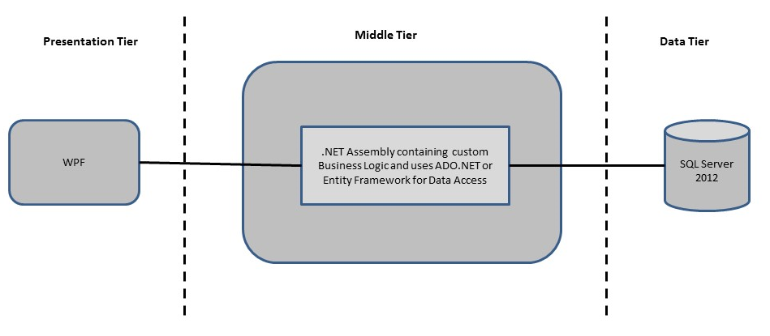

Design guidelines
- All the exceptions/errors to be captured and user-friendly message to be displayed on the Windows.
- Use ADO.NET for Data access layer. Make use of stored procedures. All the database interaction would be performed using Data Access Component. Most common methods in Data Access Component would be –
- Create Connection to the Database
- Create Command Object
- Set Command Type to Stored Procedure
- Create and Populate Parameters
- Execute the Command
- Close the Connection

Technology used:
    - Presentation Layer
        - WPF 4.5

    - Business Layer
      - Business Logic Components and Services :-
        - C# 5.0
    - Database Layer
      - Databases:-
        - SQL Server 2012

Sr. No | Course | Duration | Functionality to be built
Sr. No | Course | (in PDs) | Functionality to be built
1 | MS SQL Server 2012 | 4 | Creating relevant database tables and stored procedures
2 | NET Framework 4.5 + C# 5.0 | 7.5 | Developing Business components (C# classes)
3 | ADO.NET 4.5 | 3 | Integrating the DAL ,BLL and PL
4 | LINQ and Entity Framework | 2 | Creating data model and data context and using LINQ to Entities
5 | WPF 4.5 | 2 | Incorporating advanced UI functionality with WPF 4.5
6 | Mini Project Presentation | 1 | The Mini Project Presentation day

Note: Saturday half day will be devoted for mini project

Implementation

Summary of the functionality to be built:
The participants need to develop the Windows application for HR Management System by building the functionality incrementally in each of the course modules of .NET LOT.

Guidelines on the functionality to be built:

The functionality and components to be built in each of the course modules of .NET LOT is as follows:

1) Course: SQL Server 2012

This section describes some of the basic steps involved in designing and creation of the database for the application.

Create Data Model - identify the different tables and fields that we will need, which would later be used for building the rest of the application.

Database Schema - Create the following database tables (make your assumptions incase you require few more fields)

- Users :- UserId, UserName , Password, FirstName, LastName
- Roles :- RoleId, RoleName
- UserRoles:-UserId, RoleId
- Employee :- EmployeeID, FirstName, MiddleName, LastName, BirthDate, Age, Gender, CivilStatus, Religion, Citizenship, MobileNo, HomePhoneNo, Street1, Street2, City, State, Zip, Country, ProjectId, SkillId, EducationalBackground
- CapGeminiDetails:- EmployeeId, Email, LevelId, DateHired, Speciality, Status
- Project: - ProjectId, ProjectName, Description, Client, StartDate, EndDate
- Category: - CategoryId, CategoryName, CategoryDescription
- Skill:- SkillId, SkillName, SkillDescription, CategoryId
- CivilStatus:- StatusId, StatusDescription
- Level: - LevelId, LevelDescription
- Speciality:- SpecialityId, SpecialityName

2. Course: Winforms 4.5, WPF 4.5

a. Develop the prototypes for following functionalities:
- Main/Home Window: - This will show menu to manage Employee, Skill, Category, Project details with the option for user to login to the system (Initially all the menus will be disabled unless a user login to the system). Separate link for admin login. If the user is admin add menu to manage CivilStaus, Level and Speciality.

Employee (Including CapGemini Details):
- Add Employee Details: - This will allow the user to Add Employee details.
- Update Employee Details: - This will allow the user to Edit Employee details.
- Delete Employee Detail: - This will allow the user to Delete Employee details.
- View Employee Details: - This will allow the user to View Employee details.
Skill:
- Add Skill Details: - This will allow the user to Add Skill details.
- Update Skill Details: - This will allow the user to Edit Skill details.
- Delete Skill Detail: - This will allow the user to Delete Skill details.
- View Skill Details: This will allow the user to View Skill details.
Category:
- Add Category Details: - This will allow the user to Add Category details.
- Update Category Details: - This will allow the user to Edit Category details.
- Delete Category Detail: - This will allow the user to Delete Category details.
- View Category Details: This will allow the user to View Category details.
Project:
- Add Project Details: - This will allow the user to Add Project details.
- Update Project Details: - This will allow the user to Edit Project details.
- Delete Project Detail: - This will allow the user to Delete Project details.
- View Project Details: - This will allow the user to View Project details.

- Admin Login: - This will help to administrator to authenticate himself or herself against the database table so they can access the system to do administrative work.

CivilStatus:
- Add CivilStatus Details: - This will allow the user to Add CivilStatus details.
- Update CivilStatus Details: - This will allow the user to Edit CivilStatus details.
- Delete CivilStatus Detail: - This will allow the user to Delete CivilStatus details.
- View CivilStatus Details: - This will allow the user to View CivilStatus details.

Level:
- Add Level Details: - This will allow the user to Add Level details.
- Update Level Details: - This will allow the user to Edit Level details.
- Delete Level Detail: - This will allow the user to Delete Level details.
- View Level Details: - This will allow the user to View Level details.
Speciality:
- Add Speciality Details: - This will allow the user to Add Speciality details.
- Update Speciality Details: - This will allow the user to Edit Speciality details.
- Delete Speciality Detail: - This will allow the user to Delete Speciality details.
- View Speciality Details: - This will allow the user to View Speciality details.
User (Same for Roles and UserRoles):
- Add User Details: - This will allow the user to Add User details.
- Update User Details: - This will allow the user to Edit User details.
- Delete User Detail: - This will allow the user to Delete User details.
- View User Details: - This will allow the user to View User details.

b. In this course you need to develop the user interface using Winforms or WPF. The screens should include the fields as per the functionality mentioned above. Include Validations where ever required.

3. Course: C# 5.0 and ADO.NET 4.5

- Develop business components (C# classes) for the above functionality:

- Employee Class: - This class will contain methods for managing Employee Information.
- CapGeminiDetails Class: - This class will contain methods for managing Employees CapGeminiDetails Information.
- Project Class: - This class will contain methods for managing Project Information.
- Category Class: - This class will contain methods for managing Category Information.
- Skill Class: - This class will contain method for managing Skill Information.
- CivilStatus Class: - This class will contains method for managing CivilStatus information.
- Level: - This class will contains method for managing Level information.
- Speciality: - This class will contains method for managing Speciality information.
- User Class:- This class will contains method for managing Users Information.
- Role Class:- This class will contains method for managing Roles Information.
- UserRole Class:- This class will contains method for managing UserRole Information.

You need to create Layered Architecture which comprises of Presentation Layer (WPF), Business Logic Layer (C# Classes) and DAL Layer (Using ADO.Net 4.5 or LINQ and Entity Framework)

DAL Layer of ADO.NET 4.5 will include all the required code snippets for CRUD Operations.

All the CRUD operations should use SQL Server Stored Procedures (For Insert, Update, Delete & Search).

The connectionString should be stored in the configuration file only.

OR

4. Course: LINQ and EF
a) Using the Datbase first approach of Entity framework create a Entity Data Model form the database created in earlier steps. The Entity Data Model should consist of the following entities:

- Employee Class:- This class/entity will hold Employee Information
- CapGeminiDetails: This class/entity will hold Employees CapGeminiDetails Information.
- Project Class:- This class/entity will hold Project Information
- Skill Class:- This class/entity will hold Skill Information
- Category Class:- This class/entity will hold Category Information
- CivilStatus Class:- This class/entity will hold CivilStatus Information
- Speciality Class:- This class/entity will hold Speciality information
- Level Class:- This class/entity will hold Level information
- User Class:- This class/entity will hold Users Information
- Role Class:- This class/entity will hold Role Information
- UserRole Class:- This class/entity will hold UserRole Information

b) Using DataContext to perform CRUD operations and use LINQ to implement the required business logic in the application (like retrieving data, sorting data, searching data etc).

5. Course: ADO.NET 4.5 and WPF 4.5
  - Integrate all screens (WPF) with business components (C# classes) to complete the entire functionality.

Project Evaluation Guidelines
The project it is to be evaluated based on the following five parameters:

- Proper Database Structure and UI designing as per the specifications –(15 Marks)
  - Proper Database Design and Stored Procedure
  - Visual look and feel of the UI
- Project Completion – (20 Marks)
  - Timely Completion of the project
  - Integration of all component of the system
- Defect free execution – (30 Marks)
  - Error free execution of individual modules and the whole system
  - Validation
  - Functionality as per the specified requirements
- Compliance of standard and guidelines – (15 Marks)
  - Appropriate comments entries
  - Adherence to naming conventions for classes, functions, variables and files
  - Simplicity of user interface and screen layouts
  - Maintainability of codes (for example, no one function should be more than 100 lines)
- Group Presentation and Query handling – (20 Marks)
  - Participants (Group of 3 to 4) to present the project with UML Diagrams(use case diagram and one of the sequence or activity diagram) and PPT

